Task 1 – Roll-E’s Escape

# Luke Parnis ,Daniel Cassar ,Joana Nummelin ,Darren Camielleri

1. 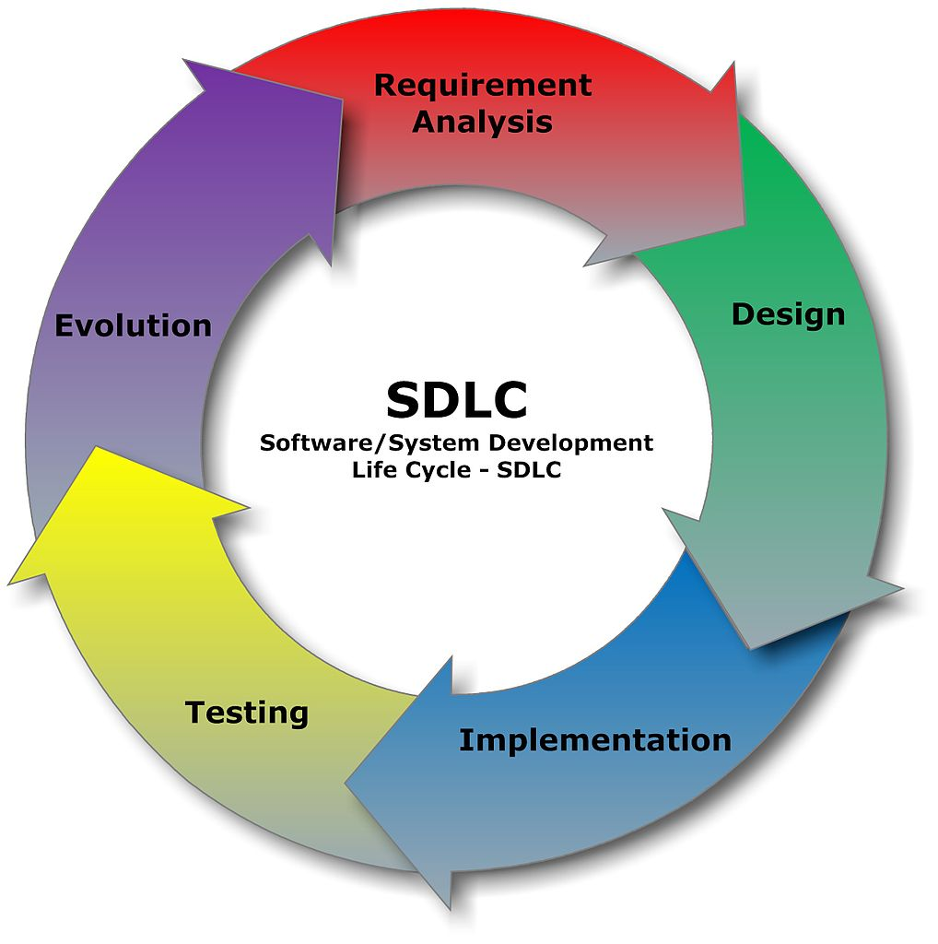The model were using to create game is the SDLC model.

* **Requirement analysis** we first came up with the ideas by combining ideas from each one ,we were doing this while we were at the AI lesson because we’re going to implement an AI in the game to combine the assignments. Then we listed all the ideas and then merged them into one after it we came up with concept and we wrote what we needed.

We also discussed how we were going to implement psychology of play in this game we decided to implement “Flow” in the game because we taught it suits the game mechanics quite well.

* **Design:** Darren started creating the 3D models for the player and the enemy AI ,the Joan started texturing the models. Luke was looking up textures for the walls and floor that we going to use.
* **Implementation: (**Talk how we coded the game**).**
* **Testing:** While creating the game we tested the game ourselves but we also going to test it on a few random people to see the reaction of people and to see if we can find more bugs in the game.
* **Evaluation :** Different version of the game(WRITE MORE HERE)
* **Mayor components** :